**IC252 - Lab 5**

**By Adarsh Santoria(B21176)**

**Questions with code and terminal displayed :-**

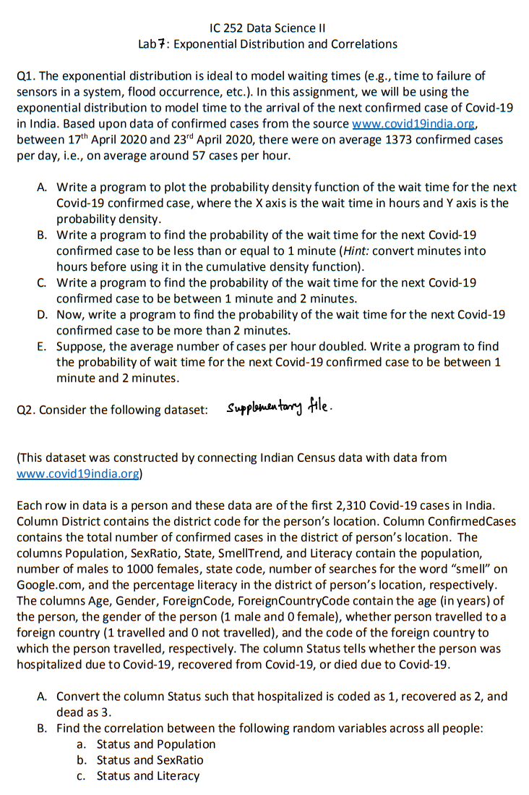

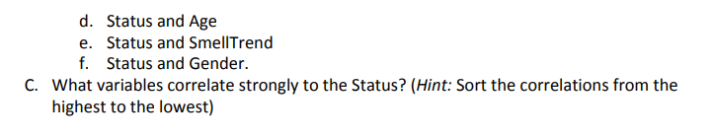

**CODE WITH OUTPUT ON TERMINAL**

